**Session 1**

1. Create a class of ArrayList and add the objects by using add method and print the all the values which you added.

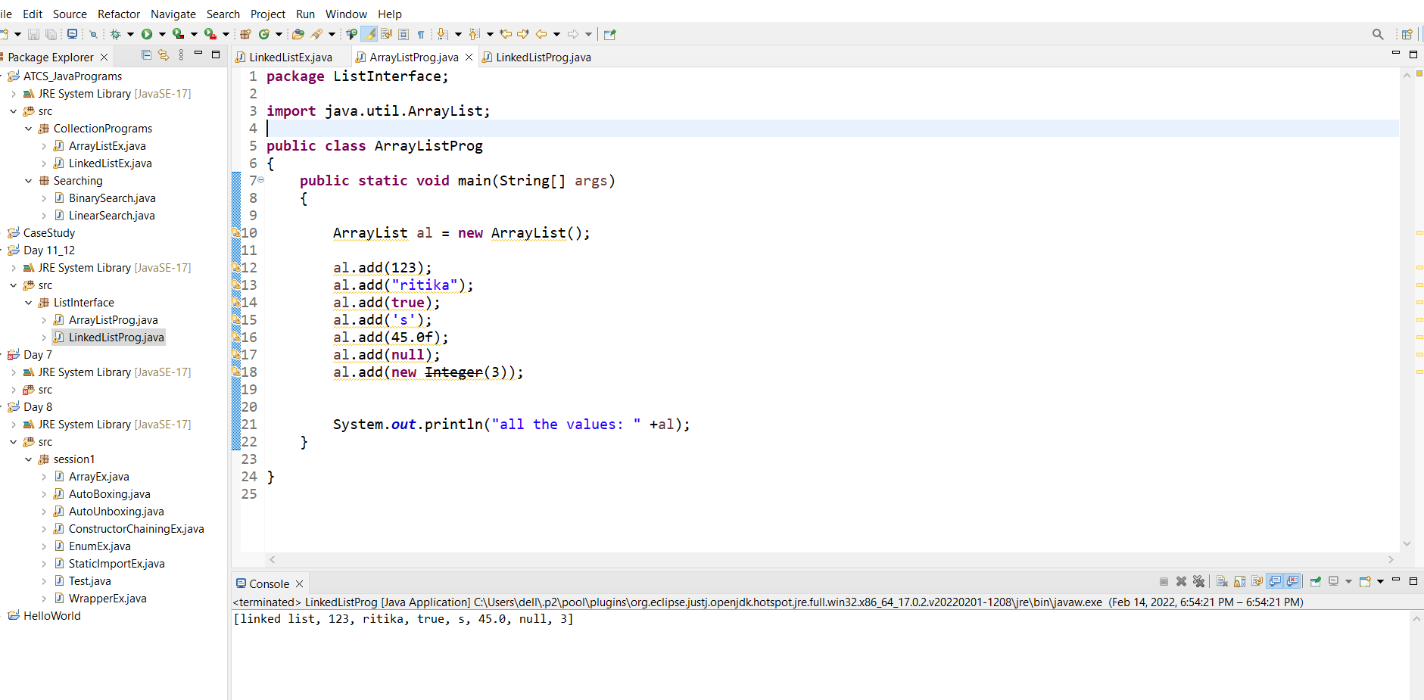

1. Create a of Linked List add the heterogenous objects print all the objects.

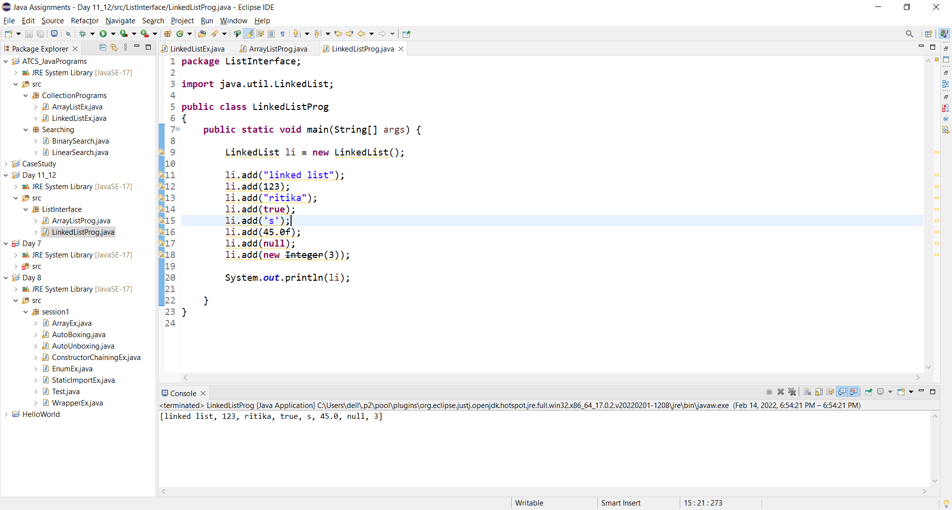

1. Create a LinkedList class and apply different methods for that class size(), contains(), isEmpty(), getFisrt(). print the results.

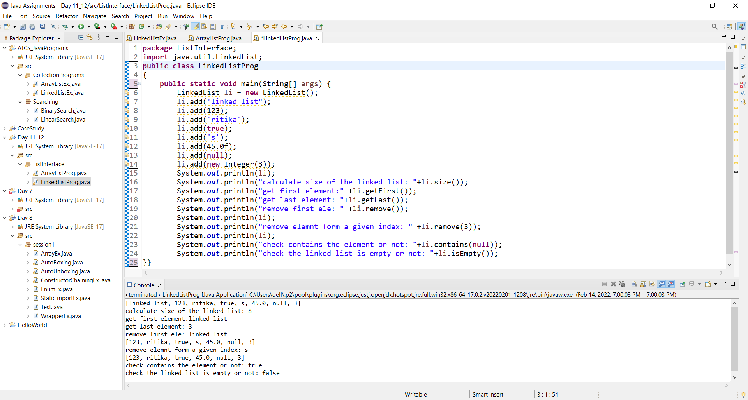

1. class name is test and taking arraylist object add different objects and print the values by using for loop and foreach loop.

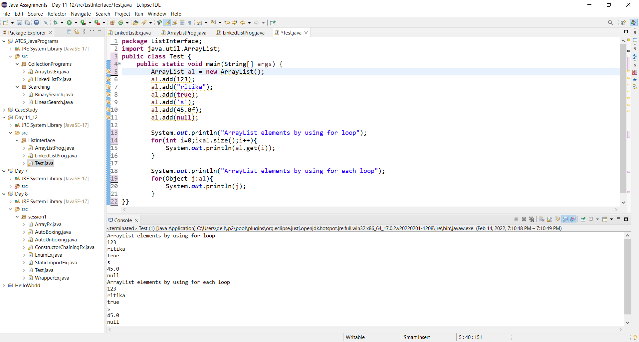

1. Create a class with generics(perticular type integer) and add the values print even numbers.

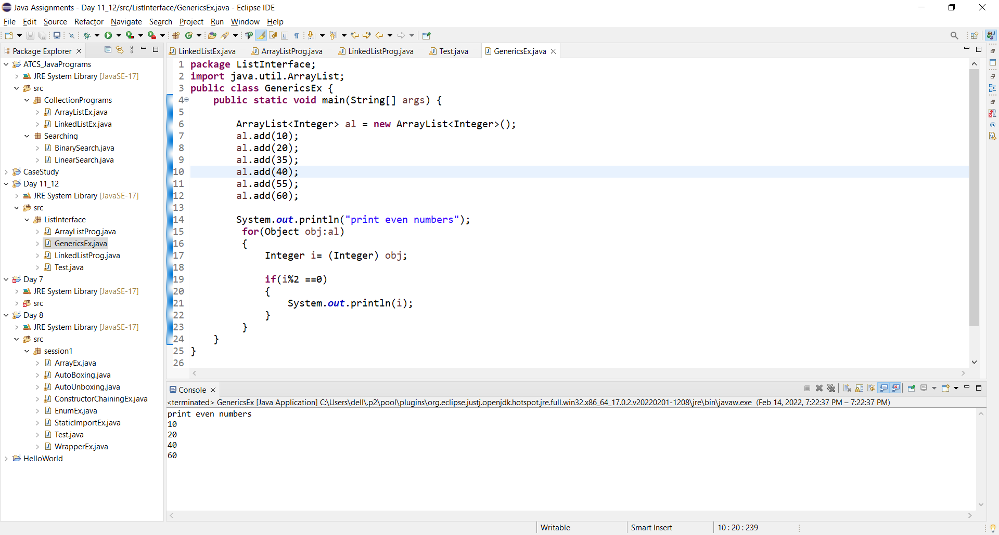

1. Create a ArrayList class by using Iterator print the values.

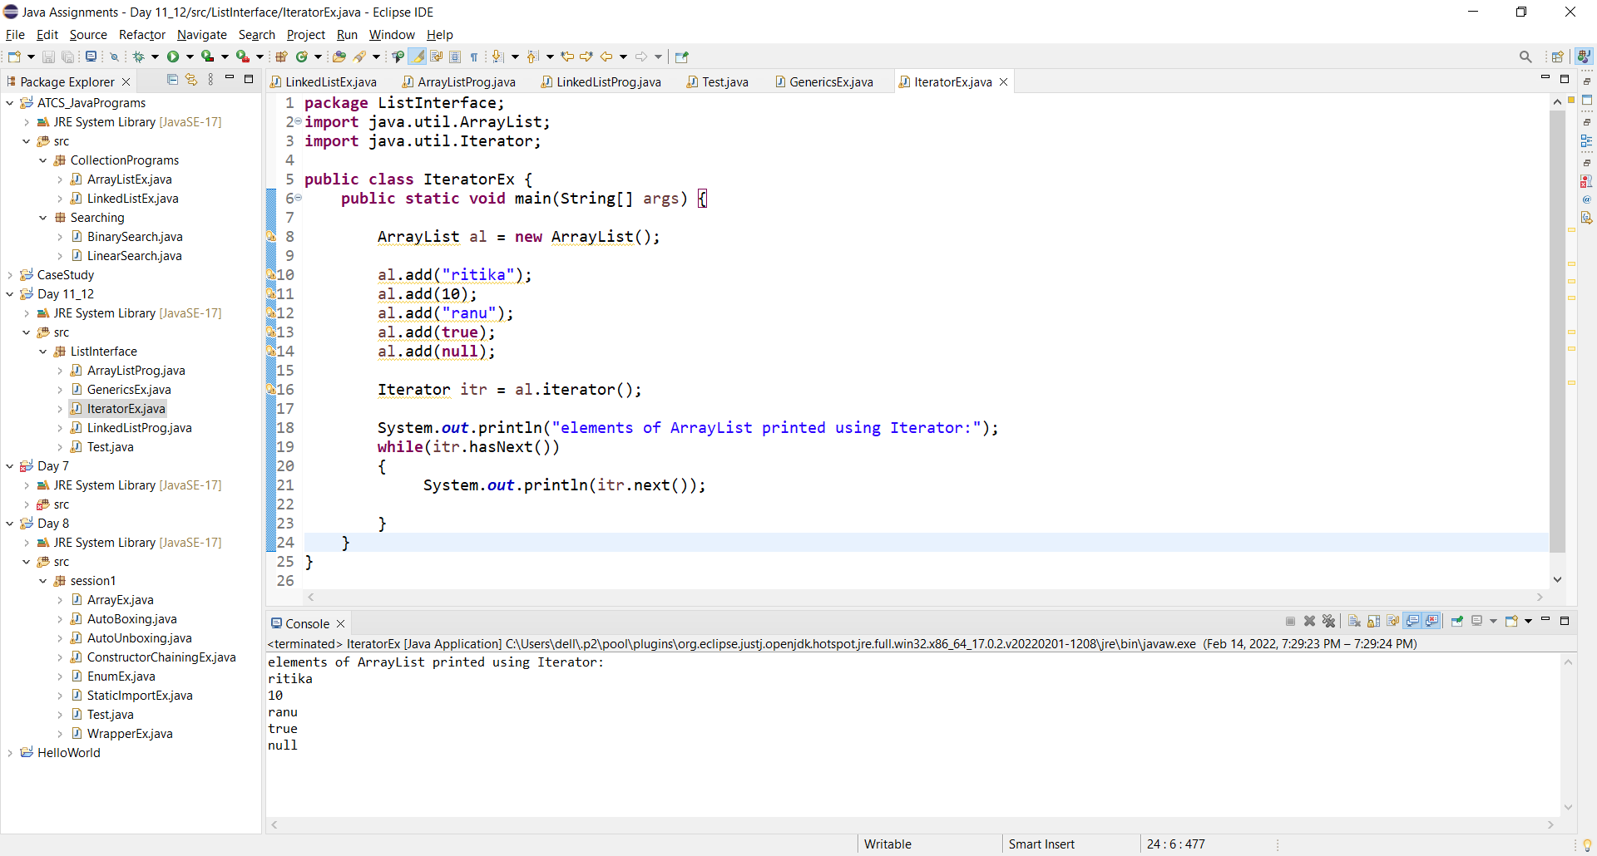

1. Create a class with generics and apply ListIterator cursor on that class and print the values.

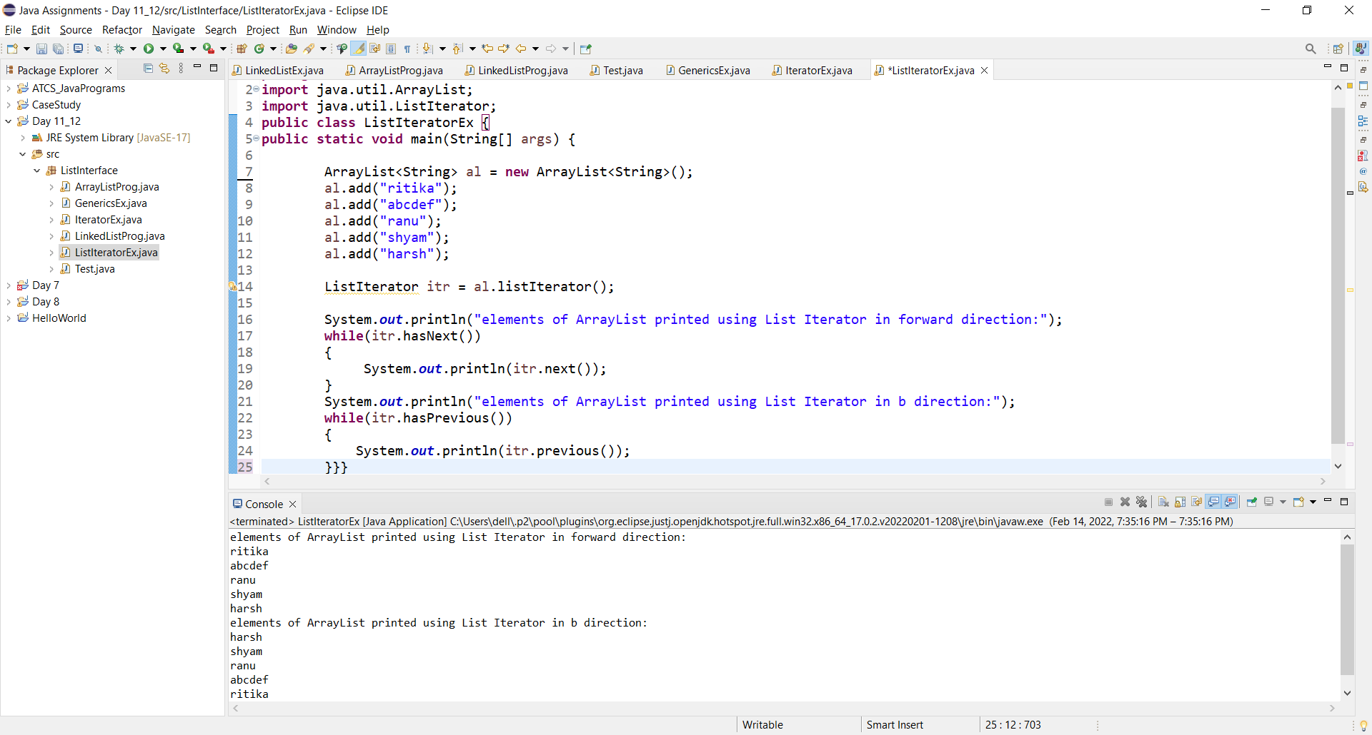

**Session 2**

1. Create a priorityQueue class add elements and print the values.

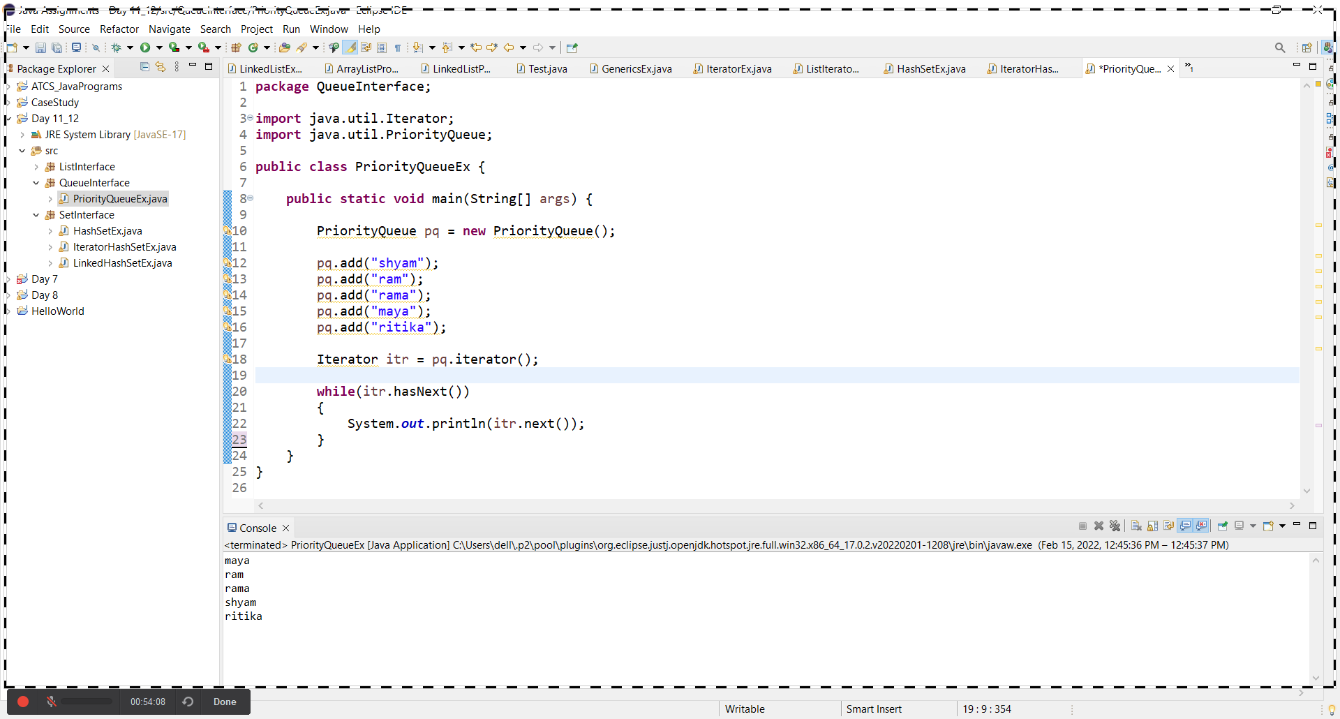

1. Create a of HasSet add the heterogenous objects print all the objects.

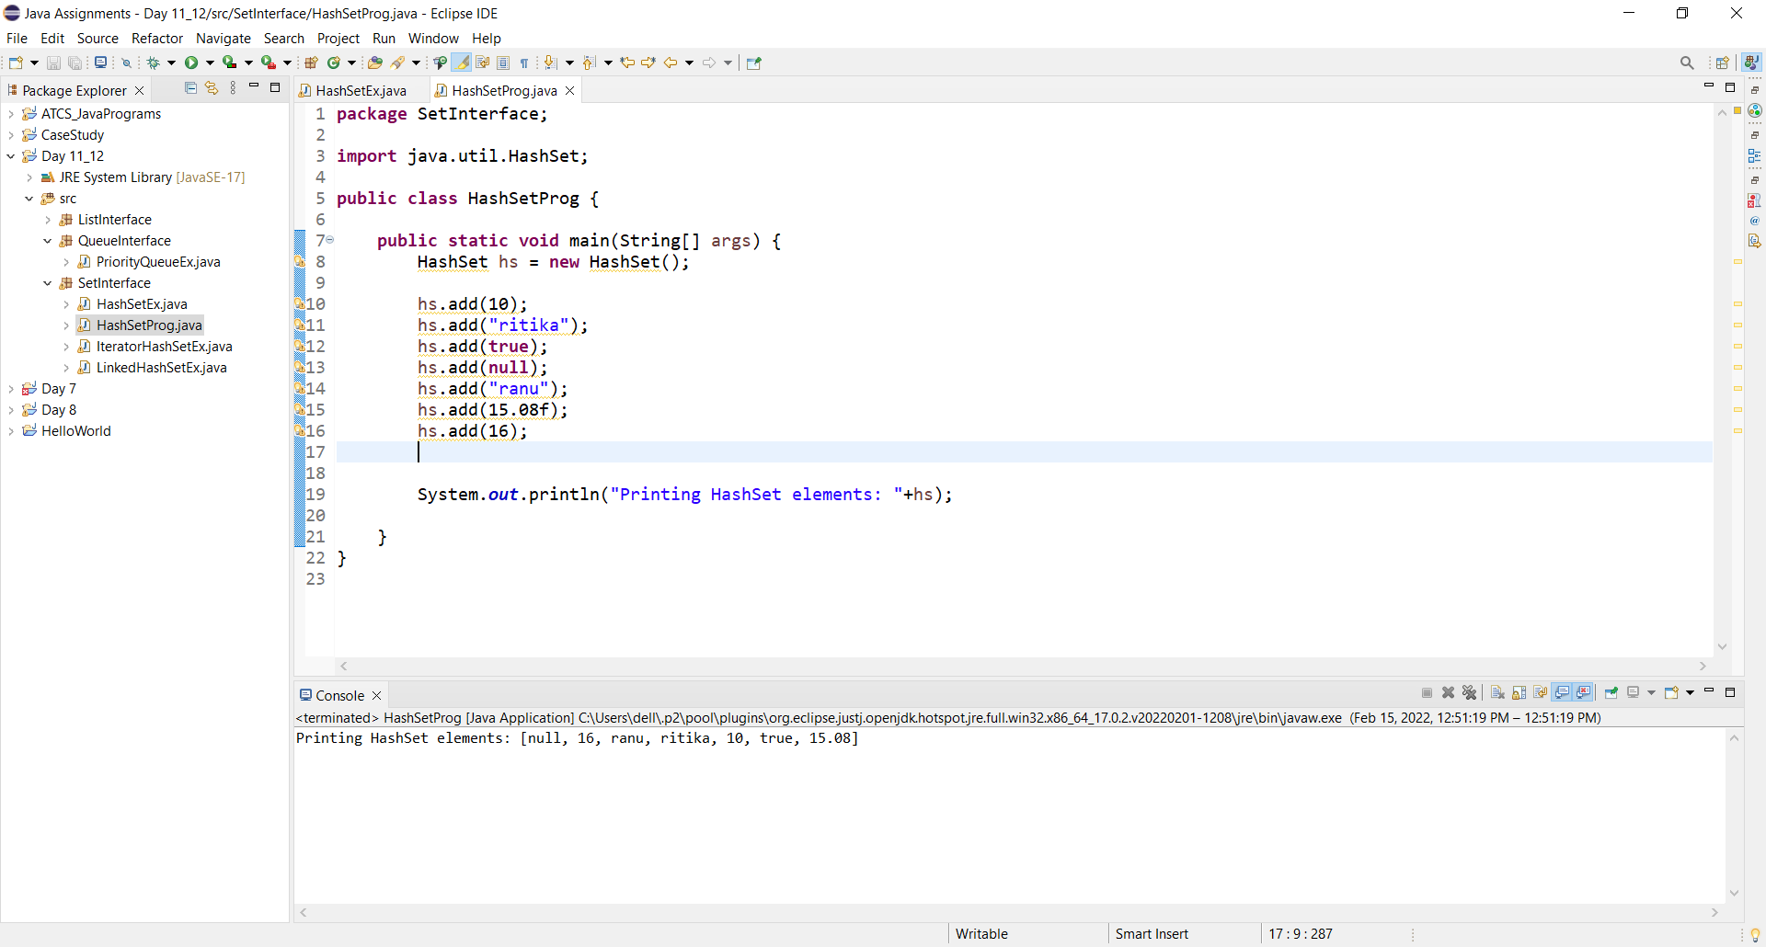

1. Create a of Linked HashSet add the heterogenous objects print all the objects.

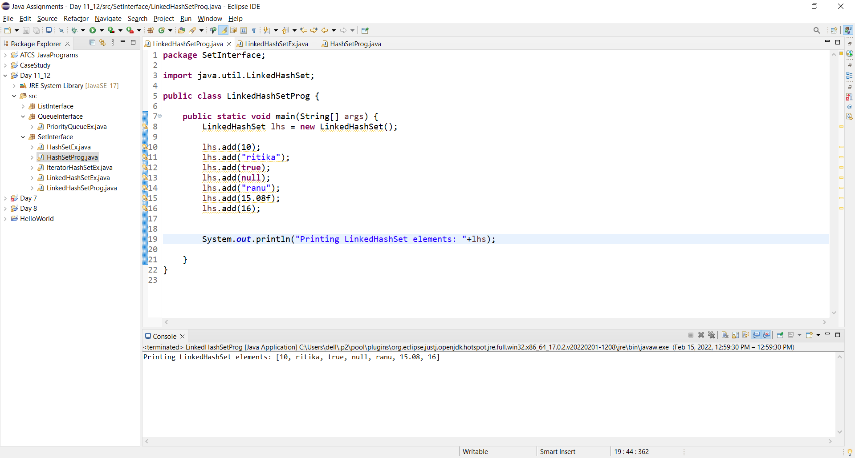

1. By using Generics create Tree Set and print the all the values.

